- Implementing Singleton pattern
public class Logger {
private static Logger instance;

private Logger() {
}

public static Logger getInstance() {
if (instance == null) {
instance = new Logger();
}
return instance;
}

public void log(String message) {
System.out.println("LOG: " + message);
}
}
public class TestSingleton {
public static void main(String[] args) {
Logger logger1 = Logger.getInstance();
Logger logger2 = Logger.getInstance();

logger1.log("This is the first log message");
logger2.log("This is the second log message");

if (logger1 == logger2) {
System.out.println("Both logger instances are the same");
} else {
System.out.println("Different instances");
}
}
}
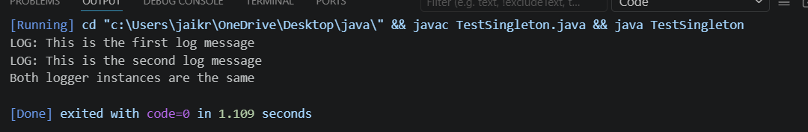
2)Factory Method Pattern
public interface Document {
void open();
void save();
void close();
}
public class WordDocument implements Document {
public void open() {
System.out.println("Opening Word Document...");
}

public void save() {
System.out.println("Saving Word Document...");
}

public void close() {
System.out.println("Closing Word Document...");
}
}
public class WordDocument implements Document {
public void open() {
System.out.println("Opening Word Document...");
}

public void save() {
System.out.println("Saving Word Document...");
}

public void close() {
System.out.println("Closing Word Document...");
}
}
public class PdfDocument implements Document {
public void open() {
System.out.println("Opening PDF Document...");
}

public void save() {
System.out.println("Saving PDF Document...");
}

public void close() {
System.out.println("Closing PDF Document...");
}
}
public class ExcelDocument implements Document {
public void open() {
System.out.println("Opening Excel Document...");
}

public void save() {
System.out.println("Saving Excel Document...");
}

public void close() {
System.out.println("Closing Excel Document...");
}
}
public abstract class DocumentFactory {
public abstract Document createDocument();
}
public class WordDocumentFactory extends DocumentFactory {
public Document createDocument() {
return new WordDocument();
}
}
public class PdfDocumentFactory extends DocumentFactory {
public Document createDocument() {
return new PdfDocument();
}
}
public class ExcelDocumentFactory extends DocumentFactory {
public Document createDocument() {
return new ExcelDocument();
}
}
public class TestFactory {
public static void main(String[] args) {
DocumentFactory factory;

factory = new WordDocumentFactory();
Document wordDoc = factory.createDocument();
wordDoc.open();
wordDoc.save();
wordDoc.close();

System.out.println("-------------------");

factory = new PdfDocumentFactory();
Document pdfDoc = factory.createDocument();
pdfDoc.open();
pdfDoc.save();
pdfDoc.close();

System.out.println("-------------------");

factory = new ExcelDocumentFactory();
Document excelDoc = factory.createDocument();
excelDoc.open();
excelDoc.save();
excelDoc.close();
}
}
